23CSE202 DATABASE MANAGEMENT SYSTEMS
S3 B.Tech CSE
Department of Computer Science and Engineering
Amrita School of Computing, Amritapuri Campus

3. Database Design Document
Group No : C16
Team Members :
Roll No | Student Name
AM.SC.U4CSE25221 | HarinandhReddy A
AM.SC.U4CSE25223 | Ganesh Innamuri
AM.SC.U4CSE25211 | Nitesh Reddy
AM.SC.U4CSE25255 | Thummalapalli Vardhan
AM.SC.U4CSE25241 | P.V.V.Charan Raj
Project Title : Alumni Mentorship Matcher

3.1. Detailed description of the project
The platform serves three kinds of people through one shared login gateway: students who want guidance, alumni who are willing to mentor, and administrators who keep the system healthy. Every person, regardless of role, is represented by exactly one row in USERS. This is the supertype entity that stores the identity data common to all three roles: username, password hash, role, full name, and the timestamp they joined.
USERS also carries two profile fields, focus_track and professional_bio, that are shared across roles rather than alumni-only. Both students and alumni fill these in through the same shared profile screen in the application, so they belong on the supertype, not on a subtype.
Only alumni carry a further, alumni-specific set of attributes: capacity status, maximum mentee count, and preferred meeting hours. These three fields are only meaningful for an account that is actively mentoring, so this scenario is modeled as an ISA (supertype/subtype) specialization. ALUMNI_DETAILS extends USERS with a one to one, partial, disjoint relationship that exists only when role = 'alumni'.
No equivalent subtype exists for the student or admin roles, and this is a deliberate omission rather than an oversight: neither role has a single attribute that is not already covered by USERS. A student's participation in the system is fully expressed through their USERS row plus the MENTORSHIP_REQUESTS rows where they appear as student_id, and an admin's role carries no data of its own beyond identity and permissions, both already present on USERS. A subtype table is only justified when a role needs to store something a plain USERS row cannot, which is true for alumni and not true for the other two roles.
The core business transaction is the mentorship request: a student browses the alumni directory and submits a pitch to a specific alumnus. This creates one row in MENTORSHIP_REQUESTS, tying together a student USERS row and an alumni USERS row along with a status that starts at 'pending' and is later moved to 'accepted' or 'declined' by the alumnus. A student may hold an accepted match with at most one alumnus at a time in the current implementation, but may address many requests to many different alumni over time, and an alumnus may simultaneously hold many accepted mentees, informally bounded by max_mentees. So the relationship between students and alumni, mediated by MENTORSHIP_REQUESTS, is many to many at the entity level even though each individual request row is a single student to alumnus pairing.
Finally, every logged-in user holds at most one active login session, recorded in SESSIONS as a one to one relationship with USERS. A token issued at login is stored server-side and must match the token a client presents on every subsequent request.
Business rules enforced by the schema and application logic:
- A USERS row's role determines which dashboard it is routed to at login. Role is set at registration, but is not permanently fixed: an administrator can subsequently change any user's role through the user management screen, at which point an ALUMNI_DETAILS row is created automatically if the new role is 'alumni'.
- An ALUMNI_DETAILS row can exist only for a USERS row whose role is 'alumni'. This is enforced at the application layer, since the current schema does not add a CHECK constraint tying the two together.
- A MENTORSHIP_REQUESTS row is required by the application logic to reference two distinct USERS rows, one playing the student role and one playing the alumni role, and its status is only ever moved forward from pending to accepted or declined, never back. None of this is guaranteed by the schema itself: the two foreign keys only guarantee that student_id and alumni_id each exist somewhere in USERS, with no constraint checking that their roles are correct, that the two ids are different from each other, or which direction a status change is allowed to go.
- A SESSIONS row is deleted or replaced when a user logs in again, since only one active token per user is permitted. Sessions do not currently expire on their own.
- Only an administrator may terminate a USERS row, and any account whose role is 'admin' is protected from termination altogether, regardless of who initiates the request. This is a blanket protection on the admin role, not only on the acting administrator's own account.

3.2. ER Diagram
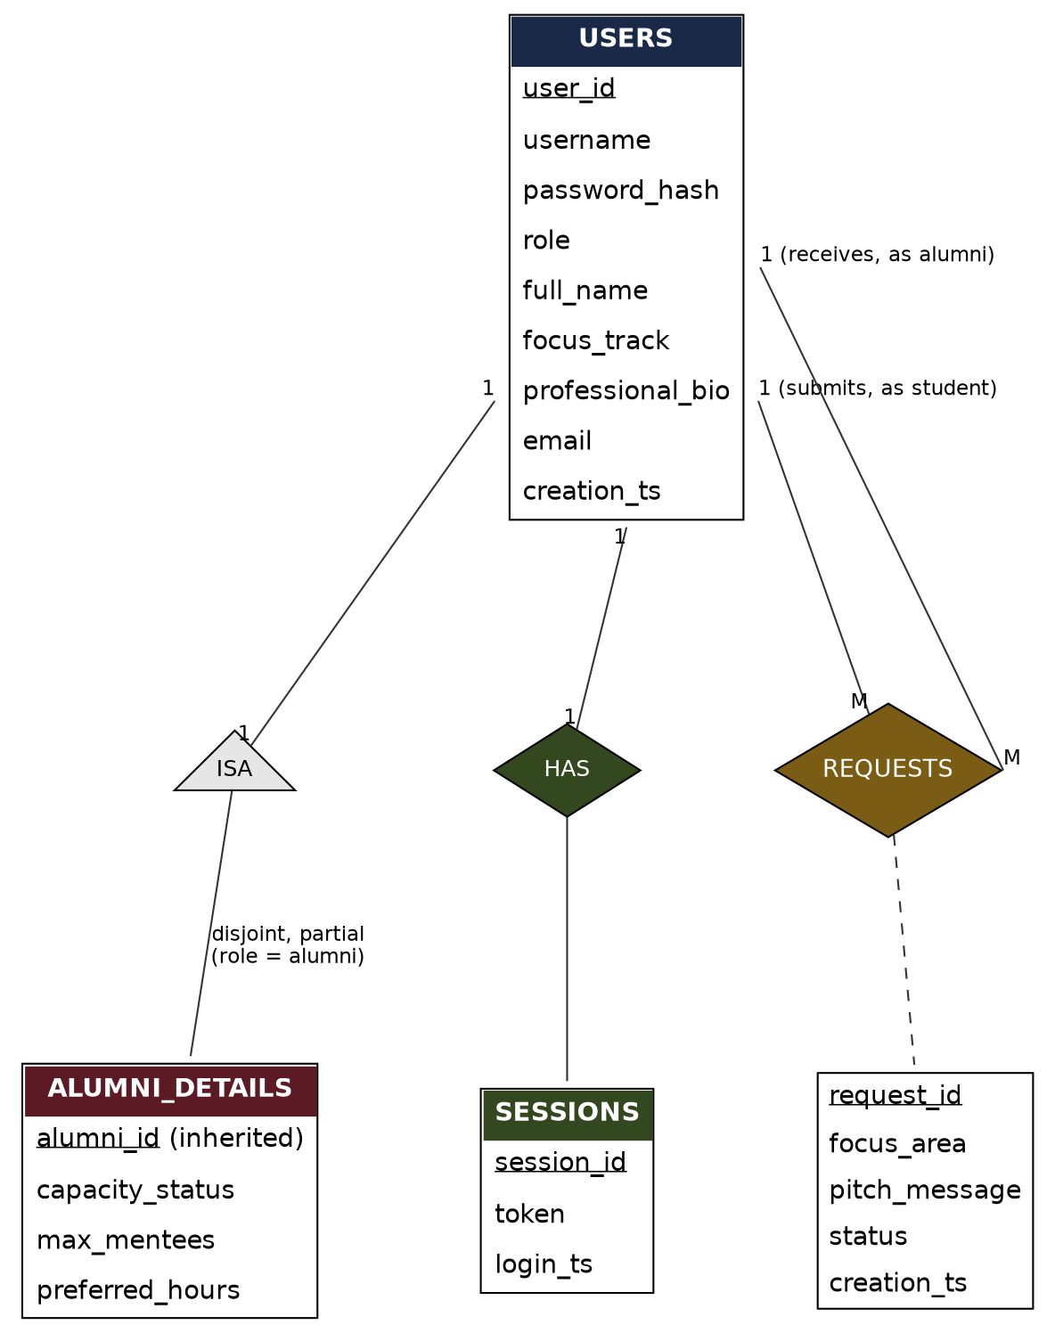
Figure 3.1: Entity-Relationship diagram for the Alumni Mentorship Matcher database.
Notation used above: rectangles are entities with their attributes listed inside, primary keys underlined. The ISA triangle is the supertype/subtype specialization between USERS and ALUMNI_DETAILS, marked disjoint and partial because only rows with role = 'alumni' are intended to participate, a rule the application enforces rather than the schema. The two edges into MENTORSHIP_REQUESTS both originate from USERS, because a request is intended to link one student-role row and one alumni-role row from the same entity set, again by application design rather than by any schema-level check on either foreign key. The has relationship into SESSIONS is one to one and mandatory on the SESSIONS side, since a session cannot exist without its owning user, but optional on the USERS side, since a user need not be logged in.

3.3 Relational Schema
Each relation is written below as it exists in the deployed MySQL schema (db/schema.sql). Primary keys are marked PK, foreign keys FK, and every FK names the USERS row it references, since USERS is the single entity that student, alumni and admin rows all belong to.

USERS
Supertype. One row per registered person, regardless of role.
Attribute | Type / Constraint
user_id | INT, PK, AUTO_INCREMENT
username | VARCHAR(50), UNIQUE, NOT NULL
password_hash | VARCHAR(255), NOT NULL (bcrypt)
role | ENUM('student','alumni','admin'), NOT NULL
full_name | VARCHAR(100), NOT NULL
focus_track | VARCHAR(30), NULLable
professional_bio | TEXT, NULLable
email | VARCHAR(120), NULLable
creation_ts | DATETIME, DEFAULT CURRENT_TIMESTAMP

ALUMNI_DETAILS
Subtype. One row per user whose role is 'alumni'. alumni_id is both PK and FK.
Attribute | Type / Constraint
alumni_id | INT, PK, FK to USERS.user_id, ON DELETE CASCADE
capacity_status | ENUM('active','paused'), NOT NULL, DEFAULT 'active'
max_mentees | INT, NOT NULL, DEFAULT 3
preferred_hours | VARCHAR(100), NULLable

MENTORSHIP_REQUESTS
The student to alumni relationship itself. No separate MATCHES table exists, because this relation already is the match.
Attribute | Type / Constraint
request_id | INT, PK, AUTO_INCREMENT
student_id | INT, FK to USERS.user_id, NOT NULL, ON DELETE CASCADE
alumni_id | INT, FK to USERS.user_id, NOT NULL, ON DELETE CASCADE
focus_area | VARCHAR(50), NULLable
pitch_message | TEXT, NULLable
status | ENUM('pending','accepted','declined'), NOT NULL, DEFAULT 'pending'
creation_ts | DATETIME, NOT NULL, DEFAULT CURRENT_TIMESTAMP

SESSIONS
One to one with USERS. A single active login token per user.
Attribute | Type / Constraint
session_id | INT, PK, AUTO_INCREMENT
user_id | INT, FK to USERS.user_id, UNIQUE, NOT NULL, ON DELETE CASCADE
token | VARCHAR(64), UNIQUE, NOT NULL
login_ts | DATETIME, NOT NULL, DEFAULT CURRENT_TIMESTAMP
Referential integrity and participation: MENTORSHIP_REQUESTS.student_id and MENTORSHIP_REQUESTS.alumni_id are both mandatory (NOT NULL) foreign keys into USERS, so a request cannot exist without both parties, though the foreign keys themselves only guarantee that each id exists somewhere in USERS, not that student_id belongs to a student-role row or that alumni_id belongs to an alumni-role row. USERS' participation in the submits and receives relationships is therefore total from the request's side and partial from the user's side, since a user may have zero requests. SESSIONS.user_id is mandatory and unique, giving the one to one has relationship. ALUMNI_DETAILS.alumni_id is both the primary key and a foreign key, which is how the ISA specialization is implemented relationally, but the foreign key only guarantees that alumni_id exists somewhere in USERS. It does not check that the referenced row's role is currently 'alumni'; keeping ALUMNI_DETAILS in step with role = 'alumni' is an application-level responsibility, not something the schema enforces on its own. All four foreign keys are declared ON DELETE CASCADE, so removing a USERS row also removes its dependent ALUMNI_DETAILS, MENTORSHIP_REQUESTS and SESSIONS rows automatically, which is what the application relies on when an administrator terminates a non-admin account.

3.4 Normalization and Functional dependency analysis
Each relation below is checked in the required order: 1NF, then 2NF, then 3NF, then BCNF, using the functional dependencies and candidate keys identified for that relation.

USERS(user_id, username, password_hash, role, full_name, focus_track, professional_bio, email, creation_ts)
Functional dependencies: user_id determines every other attribute in the relation. username also determines every other attribute, because username is declared UNIQUE and NOT NULL. email is not part of either dependency's determinant side here, since email is nullable and carries no uniqueness constraint.
Candidate keys: {user_id} and {username}. Closure of {user_id} reaches username, password_hash, role, full_name, focus_track, professional_bio, email and creation_ts, all attributes, so user_id is a candidate key. Closure of {username} reaches the same set, so username is a second candidate key. user_id is chosen as primary key, being the stable surrogate other tables' foreign keys reference.
Step 1, 1NF: every attribute holds a single atomic value and there are no repeating groups, so 1NF holds.
Step 2, 2NF: 2NF requires no non-key attribute to depend on only part of a candidate key. Both candidate keys here are single attributes, so no candidate key has a proper non-empty subset to depend on, and 2NF holds.
Step 3, 3NF: 3NF requires no non-key attribute to depend transitively on a key through another non-key attribute. The only two determinants present, user_id and username, are both candidate keys, so no non-key attribute determines any other non-key attribute, and 3NF holds.
Step 4, BCNF: BCNF requires every determinant to be a candidate key. The two determinants present are user_id and username, both already established as candidate keys, so USERS is in BCNF.

ALUMNI_DETAILS(alumni_id, capacity_status, max_mentees, preferred_hours)
Functional dependency: alumni_id determines capacity_status, max_mentees and preferred_hours. Candidate key: {alumni_id}, whose closure reaches every attribute.
Step 1, 1NF: all attributes are atomic, no repeating groups, so 1NF holds.
Step 2, 2NF: the only candidate key is the single attribute alumni_id, so there is no proper subset of the key for any attribute to partially depend on, and 2NF holds.
Step 3, 3NF: the only determinant is alumni_id itself, which is the key, so there is no non-key attribute determining another non-key attribute, and 3NF holds.
Step 4, BCNF: the sole determinant, alumni_id, is the candidate key, so ALUMNI_DETAILS is in BCNF.
This relation exists because capacity_status, max_mentees and preferred_hours describe an alumnus's current mentoring capacity, a concept that does not apply to a student or admin row. This is a narrower, more deliberate split than moving out every alumni-leaning column: focus_track and professional_bio also happen to be populated mainly by alumni in practice, but students and admins can hold values there too through the same shared profile screen, so those two stayed on the supertype. Only the mentoring-capacity attributes, meaningless outside the alumni role by definition, were factored out. alumni_id is simultaneously the primary key of ALUMNI_DETAILS and a foreign key into USERS, the standard relational encoding of a disjoint, partial specialization.

MENTORSHIP_REQUESTS(request_id, student_id, alumni_id, focus_area, pitch_message, status, creation_ts)
Functional dependency: request_id determines student_id, alumni_id, focus_area, pitch_message, status and creation_ts. Candidate key: {request_id}, whose closure reaches all six remaining attributes.
Note that (student_id, alumni_id) is deliberately not treated as a candidate key: the current implementation does not block a student from submitting a second pending request to an alumnus who already declined them once, a known, accepted limitation, so the same (student_id, alumni_id) pair can legitimately appear in more than one row over time. A surrogate key, request_id, is therefore the correct modeling choice, not a shortcut.
Step 1, 1NF: all attributes are atomic, no repeating groups, so 1NF holds.
Step 2, 2NF: the only candidate key is the single attribute request_id, so no attribute can partially depend on part of it, and 2NF holds.
Step 3, 3NF: request_id is the only determinant present, and it is the key, so no non-key attribute determines another, and 3NF holds.
Step 4, BCNF: request_id, the sole determinant, is the candidate key, so MENTORSHIP_REQUESTS is in BCNF.

SESSIONS(session_id, user_id, token, login_ts)
Functional dependencies: session_id determines user_id, token and login_ts. user_id also determines session_id, token and login_ts, and token also determines session_id, user_id and login_ts, since both user_id and token are declared UNIQUE and NOT NULL.
Candidate keys: {session_id}, {user_id} and {token}. Each closure reaches every attribute in the relation, confirming all three as candidate keys. session_id is retained as primary key, being the surrogate.
Step 1, 1NF: all attributes are atomic, no repeating groups, so 1NF holds.
Step 2, 2NF: all three candidate keys are single attributes, so no partial dependency is possible, and 2NF holds.
Step 3, 3NF: the three determinants present, session_id, user_id and token, are all candidate keys, so no non-key attribute determines another, and 3NF holds.
Step 4, BCNF: every determinant present is a candidate key, so SESSIONS is in BCNF.
Across all four relations, every candidate key turned out to be a single attribute, which is why 2NF was satisfied at the point 1NF was confirmed: a partial dependency needs a composite key to attach to, and none exists here. The step was still checked explicitly for each relation above rather than assumed. The one substantive normalization decision in this design was factoring the mentoring-capacity attributes out of USERS into ALUMNI_DETAILS through ISA specialization, for the reasons given under ALUMNI_DETAILS: those attributes are meaningless outside the alumni role, whereas focus_track and professional_bio are genuinely shared across roles and correctly remain on the supertype.

